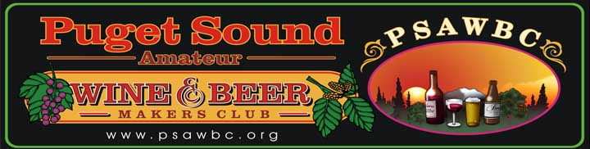

GENERAL BUSINESS MEETING
1ST Friday of every month
Federal Way Senior Center
4016 S 352nd St, Auburn, WA 98001

Do you have?
- A wine or beer making hobby that you wished you could share with other?
- A burning curiosity about what’s involved in making your own beer or wine?
- Fond memories of Grandma’s homemade wines?
- Too much fruit harvest and too few ways to use it?
- One Friday night a month free?

On the first Friday of every month (except July) the club meets at the Federal Way Senior Center, just off Highway 18.

The events scheduled include:
6:30 pm Social half hour: wine and beer makers bring their creations to share with others
7:00 pm Potluck dinner: bring a main dish, side dish, salad, or dessert
8:00 pm Monthly meeting: club business, upcoming events, educational information, etc.

The Puget Sound Amateur Wine and Beer Makers Club is a social club comprised of people with all levels of winemaking and home brewing experience, or an interest in learning the process. The club meetings give members a chance to compare notes with each other as they discuss and enjoy their homemade wines and beers. Members learn about outside competitions, availability of wine and beer making materials, and more. Club activities include wine tours, holiday parties, and a picnic for members and their families. We also host The Washington State Fair Amateur Wine and Beer Competition and have a club booth during The Fair.

Website: PSAWBC.org
Email: psawbc@yahoo.com
Follow us on Facebook!

