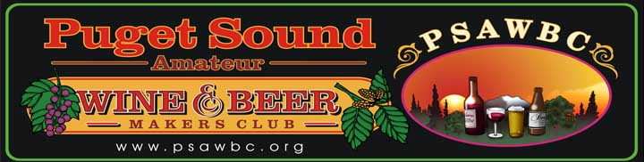

IPA EXTRACT BREW
Beer Style: India Pale Ale with raspberries/Extract

Description: This is very aromatic with hints of citrus and raspberry. An offwhite head with a perfect lace all the way to the bottom. Sweet start with the most pleasant hint of raspberry and a thirst quenching bitter. Yield 5 gallons

Ingredients:
- 9 lbs light DME
- 2 oz Columbus pellet hops
- 4 oz Centennial pellet hops
- 2 tsp Irish moss
- 1 packet dry American Ale yeast
- 5 lbs fresh raspberries
- 1 cambden tablet
- 2 tsp pectic enzyme
- ½ cup corn sugar (priming)
- OG. 1.074 FG:1/004
- Primary ferment: 8 days
- Secondary ferment: 7 days

Procedure:
Bring 3 gallons water to a boil. Remove from heat and add malt extract. Bring back to boil. Add all of the Columbus hops. After 20 minutes add 1 oz Centennial. At 40 minutes add 1 more oz Centennial and Irish moss. At 60 minutes remove from heat and add 2 oz Centennial. Add 2 gallons cold water to primary, add wort and top off to 5.5 gallons. Once its room temp pitch the yeast. After 1 week in primary, get raspberries ready with pectic enzyme and cambden. Wait 24 hours and rack beer to secondary and pour the raspberries in last. Let rest for one more week then bottle.

